**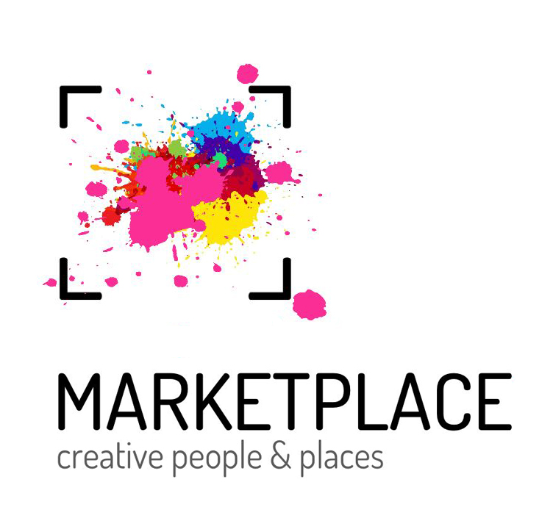*Light Up The Town* application form**

Deadline for submissions: Monday 25 November 2024, 5pm

To submit:

1. Download and complete the application form
2. Submit one document (up to three pages) showing examples of your work.
3. Email both the completed form and the examples of your work to community@cppmarketplace.co.uk with the subject line: “Light Up The Town application, [your name].”

**Useful Information**

* We aim to ensure the selected commissions will be high-quality work and provide the best experience for the artists and our community. A panel of the MarketPlace team alongside community representatives will assess the applications.
* Your applications will be viewed and selected by people who may be unfamiliar with the terminology and references of the arts and culture sector.
* We are here to help! If you need assistance with your application, have any questions about the project, or have any issues when sending required files, we’re here to support you! Please contact us at: [community@cppmarketplace.co.uk](mailto:community@cppmarketplace.co.uk)
* If you prefer to upload video responses to your application, videos should be no longer than 5 minutes each.

| Name |  |
| --- | --- |
| Pronouns |  |
| Email |  |
| Phone number |  |
| Address |  |
| Website |  |
| Occupation - Are you a freelance artist? Or are you applying as an organisation/collective? Tell us in less than two sentences about you. | |
|  | |
| 1. In no more than 1,000 words please describe the format and content of the workshop and resources you are proposing for ***Light Up The Town*** | |
|  | |
| 1. In no more than 500 words please tell us about your experience designing and delivering workshops/ community work / projects of a similar scope or scale | |
|  | |
| 1. A simple budget outline including details of your artist fee/daily rates/outline costs for the £5,000 production budget. | |
|  | |